**LAB PROJECT  
&  
OPEN ENDED LAB REPORT**

**Phone Contact Management System**



**SPRING 2025**

**CSE102L COMPUTER PROGRAMMING LAB**

Submitted by:

Muhammad Jalal Khan (23pwcse2262)

Muharram Ali (23pwcse2279)

Class Section: A

Submitted to:

**Engr. Abdullah Hamid**

3rd July , 2025

Department of Computer Systems Engineering

University of Engineering and Technology, Peshawar

**Project Title: Phone Contact Management System**

**Project Objective:**

* To make a phone contact management system that is able to to create , search ,update and delete contacts .
* To make the system such that it is able to save the added contacts permanently to disk.

**Open Ended Lab Statement:**

Your Project must contain the following points:

* The program must serve a real-world problem using concepts of OOP and File IO.
* You must use Structures or Classes in some context and utilize fstream library in C++.
* The program code must be modular.

**Project Flow Chart:**

**Project Code Screenshots:**

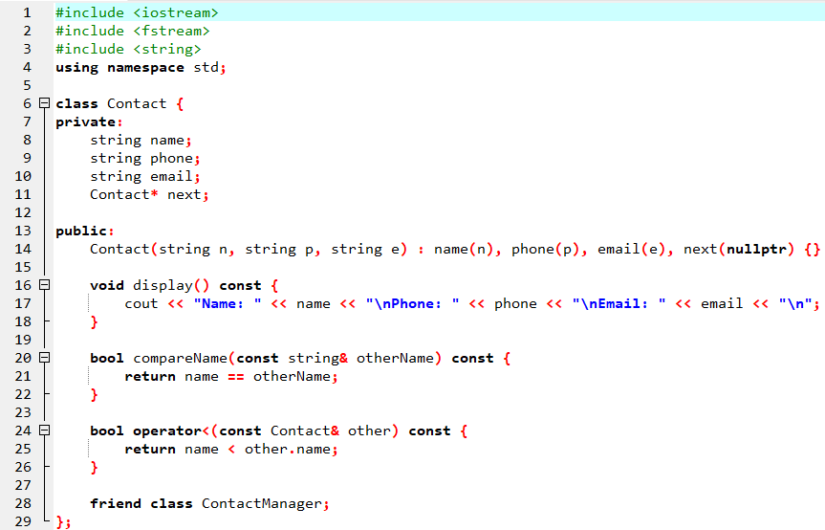

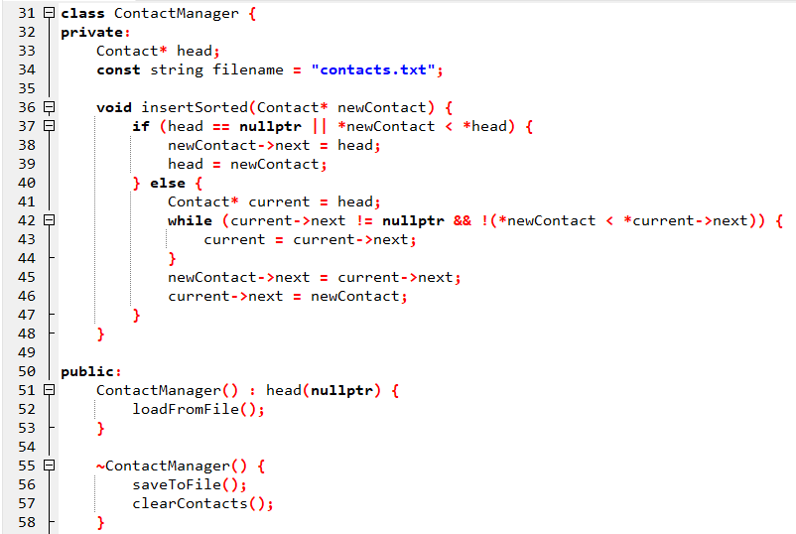

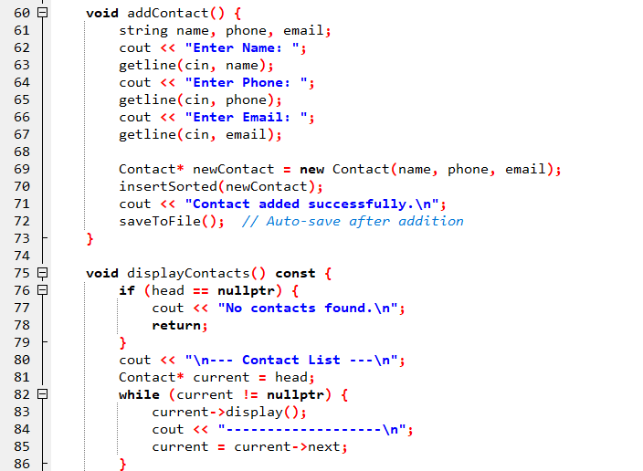

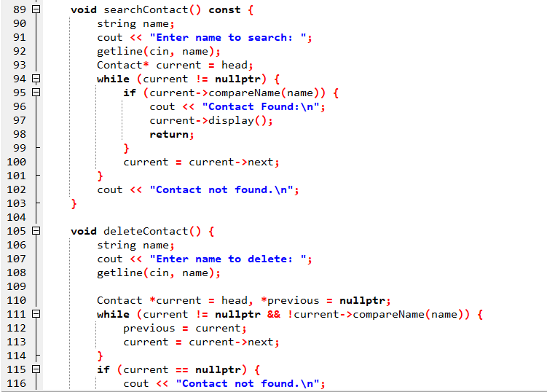

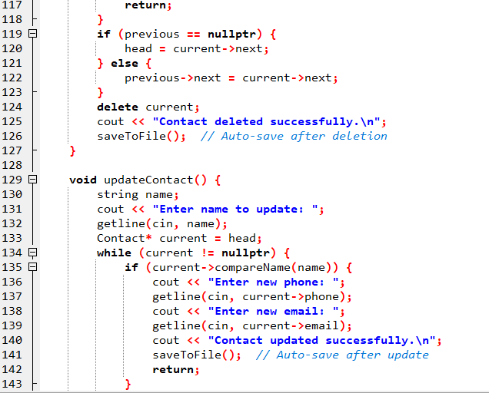

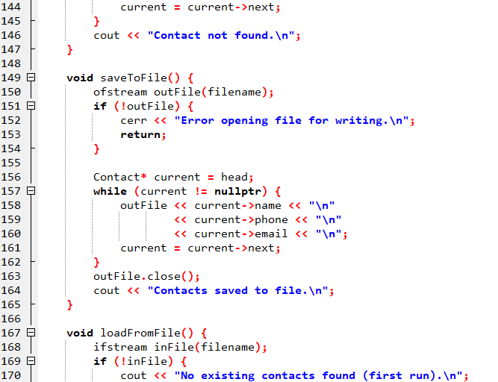

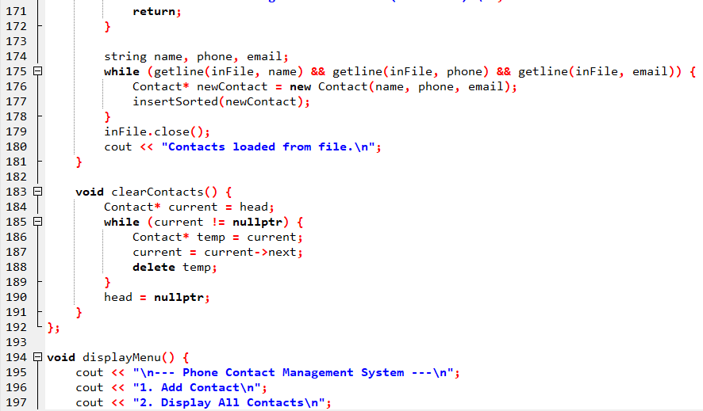

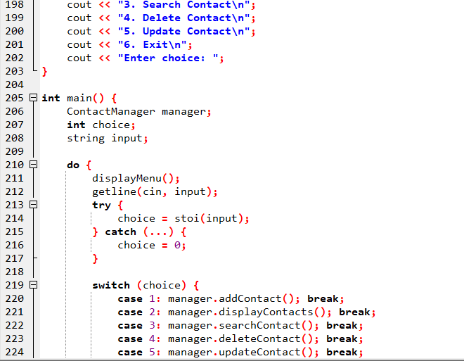

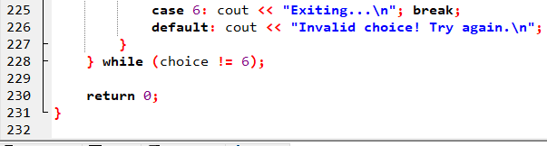

**Project Output Screenshot:**

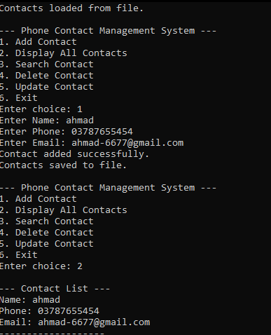

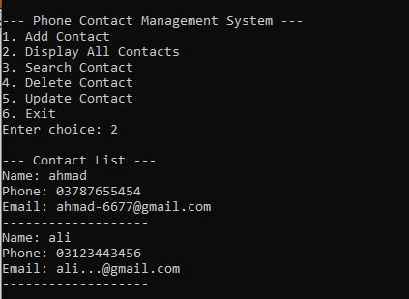

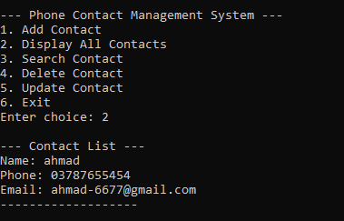

**Group Members Contribution**

* Both group members worked together , thought for the project functions to be included .
* Muharram Ali coded for the functionality of programs .
* Muhammad Jalal Khan worked for data structures .
* Lab Report made by Muhammad Jalal Khan.
* Project program’s flowchart designed by Muharram Ali.